The Three Lessons
from the Prisoner of the Truck
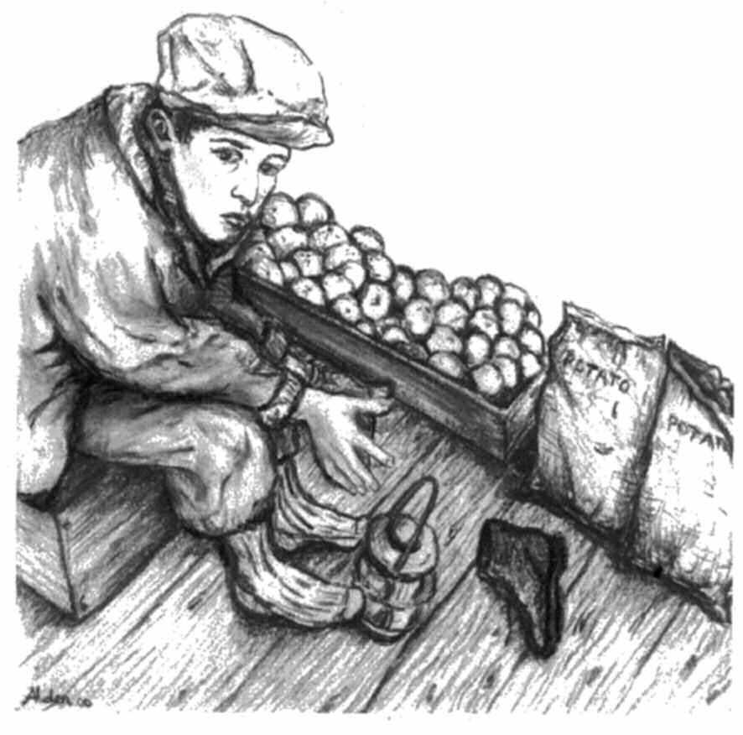

A play based on
Yes Pa:
Lessons in Character
by Fred W. Sarkis

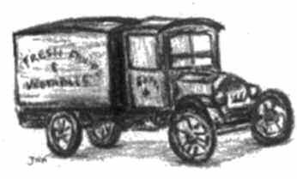

Versión 2
Running time: 15 min

Regional & national character education teachers, mentoring organizations and correctional officials volunteered significant assistance in the development of this free character-building program. Independent research studies with all of these institutions reflect positive outcomes. Yes Pa is electronically and freely provided by the Yes Pa Foundation, a not-for-profit 501 (c) (3) corporation. Visit www.urnewman.org/yespa for free PDF downloads of the various character education resources, testimonials, etc., that complete this character-building program.

The Three Lessons
from the Prisoner of the Truck

Lessons of Personal Responsibility

The Yes Pa curriculum is based on Fred Sarkis’s book, Prisoner of the Truck, and the real lessons he learned from his father as a child. This true story starts with Fred’s perception of a childhood prison on his immigrant Lebanese father’s fruit and vegetable truck. It was a 6-day, 100-hour-a-week job as Fred's Pa went door-to-door selling the fresh fruits and vegetables he’d purchased from farmers.

At age 8, in the summer, while other kids were playing on the sidewalks and streets of Rochester, NY, Fred had to work on the truck. During school months, Fred especially hated work on Saturdays. It was 5:00 a.m. to 11:00 p.m., the last call being at a bar.

In school, Fred didn’t like being called a pigeon-toed, bow-legged, knock-kneed, or dark-skinned boy. He hated school and did poorly. He sulked from age 8 to 12. The only communication he had with his father was answering, “Yes, Pa,” when his father ordered him around. At age 12, three 5-minute talks with his father changed Fred’s attitude and life.

Tips for the Presentation of the Three Lessons:
- best for students in Grades 4-6
- be straight-forward
- be as creative as you like with setting and props
- actors, make the parts your own,
- be authentic,
- make the story real

Cast of Student Characters: Costume Suggestions:

Fred Sarkis as an Adult Shirt and Tie
Narrator Attire to Fit the Part
Fred Sarkis as a Boy Work Shirt, Jeans, and Cap
Mike (Fred’s Father) Flannel Shirt and Jeans
Lady Customer Attire to Fit the Part

*Use your own creativity.

Introduction

(Fred comes forward as an adult in shirt and tie)

FRED

I am Fred Sarkis. I became a millionaire and a responsible person because of the lessons of personal responsibility that I learned from my father. Once I embraced three simple messages, I began to excel in school and obtained a business school education at the age of 16. At age 17, I bought my mother a house. I joined the Navy at age 18. As the oldest of 10 children, at the age of 24, I became the head of the family when my Pa passed away at 54 years of age. I earned my first million dollars at the age of 34. I built a major ski area and lake village, lost it all, and recovered.

I retired at the age of 65 and became an author and public speaker. Over the past 26 years, with the help of character education teachers and others, I created the Yes Pa Character Education program based on my experience as a Prisoner of the Truck.

You may be wondering, “How did he get to be so successful?” At this point in time, we will tell you.”

(Fred removes his dress shirt and puts on his flannel shirt)

NARRATOR

Fred’s father, Mike, was a huckster. He loaded the back of his truck with fresh fruits and vegetable early in the morning. He spent his day selling produce from the back of his truck in order to support his family. When Fred was 8 years old until he was 14, he worked on the truck with his father.

FRED

I was on the Prison-Truck from the time I was eight years old, until I was fourteen. Between the ages of six and eleven, I did not like who I was. I was a sad and lonely young boy. I often felt sorry for myself. I was drowning in self-pity. My father and I rarely spoke and I still answered most of his questions with, “Yes, Pa.” This is my story.

First Lesson

NARRATOR

The first lesson came early in the summer and just after school was out. At this point in life, there were seven children in his family. It was the strawberry season and Fred’s father, Mike, wanted to make a few extra dollars for his family. During the three-week strawberry season, he would buy several crates of strawberries at the public market. Along with Fred, he would also bring his eight-year-old brother, Joe, in order to help sell strawberries on the truck, after taking care of the regular customers.

FRED

Around seven o‘clock in the evening, we would begin on a narrow street in downtown Rochester. Joe and I got two baskets, a basket to carry in each hand. In each basket, we would place three smaller quart baskets of strawberries. My father told me to cover one side of the street, while Joe covered the other side. As we rang doorbells or knocked on doors, my father would drive his truck ever so slowly, slightly ahead of us, yelling over and over:

MIKE

“Berries, berries, homegrown strawberries!”

FRED

He wasn’t yelling like he would when he was mad. He kind of chanted and half sang his song to the would-be buyers. In my mind, I can still smell those luscious, ripe strawberries, and hear his strong voice filling the air as it drifted between the rows of houses, through the front screen doors, on those warm summer evenings. That particular evening, after calling on about 30 homes, I came back to the truck to get six more boxes of strawberries. My warden’s voice was gruff and angry. He said,

MIKE

Fred where have you been? You must be doing something wrong?

FRED

What do you mean, Pa?

MIKE

Your brother is only eight-years-old and you are twelve, yet he comes back to the truck for more strawberries four times to your one. What are ya doin’ wrong?

NARRATOR

Only a few months before the strawberry season, Fred had received Confirmation in the Catholic Church. This meant that he was supposed to receive the Seven Gifts of the Holy Spirit. One of those gifts was fortitude, or courage. He had learned that courage made it possible for the Twelve Apostles to spread Christ’s Good News throughout the world. Fred wanted to show courage and this was his chance, so in the strongest voice he could muster up, he said,

FRED

Maybe it’s because he has the better side of the street!

MIKE

No Ba, you are doing something wrong. I am going to watch you.

NARRATOR

"Ba," even though it meant "father" in Arabic, was a slang term used by many Lebanese fathers when they were talking to any of their children, or even when you talked to them.

FRED

I wanted the world to open up and swallow me. My warden had ordered me around for four years. He got me up at four in the morning. He made me a prisoner for one hundred hours a week. He made me sit in the back of that Prison-Truck until all hours of the night, even during the winter. All I ever did was obey him. All I ever did was say, “Yes, Pa,” and now he was going to humiliate me in front of a customer by standing over me to make sure I was selling strawberries the correct way. I was bitter and angry. I wasn’t happy about this, but I had no choice. I went to the next house while he stood directly behind me. I knocked on the door. The lady of the house finally appeared at the screen door and said,

LADY CUSTOMER

Good evening young man, and what might you have there?

NARRATOR

With drooping arms, Fred held the two flats of berries. Knowing she probably didn’t want to buy any strawberries anyway, with a doubtful look in his eyes, and his head shaking a “no,” Fred mumbled:

FRED

You probably don’t want to buy any strawberries, do you ma’am?

NARRATOR

As he was shaking his head no, the lady, looking puzzled at Fred’s warden behind him, started shaking her head no.

LADY CUSTOMER

I guess not today son.

FRED

After all, I thought, if she wanted the strawberries, she would have asked how much they cost. And if she thought the price was fair, she would have bought the amount she wanted, right? I was glad my father did not embarrass me in front of the lady. He walked me back to the truck.

MIKE

Do you want to get home early or stay out here all night?

FRED

Yes, Pa, I want to go home early.

MIKE

We will go home when we sell all of these strawberries. There is a smart way to sell strawberries and your way. I will show you the smart way. Are you ready to learn, Ba?

FRED

Yes, Pa.

NARRATOR

He took the two flats of berries out of Fred’s hands and walked up to the next house. He gently placed the two flats of strawberries on the porch floor and selected the quart basket with the reddest, plumpest berries in it. Then he brushed off his pants, stood erect, put a big old smile on his tired face and rang the doorbell. He was ready for the lady of the house. After a few seconds, a woman appeared at the door.

MIKE

Good evening, ma’am. These strawberries were picked early this morning on a farm not far from here, in Webster, New York.

NARRATOR

As he held the quart of strawberries closer to the lady’s face, he said,

MIKE

Look. See how fresh they are.

NARRATOR

Then he shifted his body and turned the basket so the lady could see that there were no bad berries at the bottom. Then he said, with excitement in his voice,

MIKE

You see, there is not one bad berry in the whole quart. No mold. No green berries. No bad ones.

FRED

With a Cheshire-cat smile on his face, Pa said,

MIKE

They are only ten cents a quart or three quarts for a quarter. Do you want one or three, ma’am?

FRED

The lady only had a choice between one and three, not yes or no. To my utter amazement, she said,

LADY CUSTOMER

I’ll take three, sir.

FRED

As we descended the porch steps, my father said,

MIKE

Now, do you think I was just lucky or that it’s the right side of the street?

FRED

I thought maybe it was just luck, but I just said, “I don’t know!” “Okay,” he said, “we’ll try the next house.” He gave the same happy sales pitch to the next lady, and she too took three. “Now,” he said in a stern voice,

MIKE

Do this from now on, and we’ll go home a lot sooner. Do you hear me, Ba?

FRED

Yes, Pa.

Right then and there, I became a believer in the delivery. I practiced and perfected the new skill I had just learned. Even though my little brother was naturally outgoing, and I was inherently shy, I quickly learned the smart art of selling strawberries. I caught up with and surpassed the strawberry sales of my little brother, Joe. This first five-minute lesson from my warden had a big impact on the rest of my life. It changed my attitude from negative to positive. I immediately stopped being shy and timid. I became friendlier and happier. Those ladies were buying fruits and vegetables from a young boy who showed enthusiasm and excitement for life and the product he was selling. Consequently, they did not see a skinny, sad young boy. They saw the shining personality of a boy who believed in himself and the product he was selling. And it wasn’t just a sham or a con job. The fruits and vegetables that my father and I sold were some of the best in Rochester. I was a good young man, hardworking, and a darned good salesman. From that day forward, I tried to remember and incorporate that life lesson into everything I did or said. I was grateful to my father for that five-minute lesson that would change my outlook on life forever.

I even thought back to my first-grade teacher, Sister Theonilla, and all the kids in my class. Maybe if I had been more positive and outgoing, I would have made more friends. Maybe if I let the light of my enthusiasm shine, I would have received as many valentines from my classmates. Maybe if I was friendlier and smiled a lot, I wouldn’t have felt so lonely and dejected. Maybe! Maybe!

It’s almost like we all have this invisible control panel on the side of our body that controls our attitude and enthusiasm. And there’s a knob that you can turn to low, medium, or high. I know it’s not scientific, but I have seen many people with their attitude knobs set at different levels. I also know that people can choose to move that knob; they can change their outlook on life. From that day on, I realized that I was in control of my attitude and enthusiasm, and I could turn my knob as high as I chose to.

Second Lesson

NARRATOR

During that same summer and shortly after the strawberry lesson, Fred’s father had another little chat with his son—the second lesson. Like the previous lesson, this one involved the way Fred was doing his job. He had just completed delivering two large baskets of fruits and vegetables to a customer who lived on the third floor of an old apartment building over on East Avenue, and there was no elevator. When he got back into the truck, he hopped back up into the cab next to his warden-father. His father looked at him with a puzzled look on his face and said,

MIKE

“Where are the empty baskets?”

FRED

Knowing that we called on this particular customer every other day, I sheepishly said, “I forgot them. I’ll pick them up day after tomorrow, okay?”

MIKE

No, you go get them now. They are worth $0.05 each.

FRED

At that moment, I again thought of the gift of courage—one of the gifts I was supposed to receive when I received the Holy Sacrament of Confirmation in our church. I also knew that I was hot and tired. No way did I want to trudge all the way back up those three flights of stairs for two baskets. I wondered if and when I would ever be able to use that gift of courage when talking to my warden. I thought, “I’m twelve-years-old. Do I speak up, or as always, just obey by saying, yes, Pa?”

NARRATOR

Fred thought, “This is the time. I will speak up.” In a soft, but positive tone of voice, he replied,

FRED

“Pa, you don’t pay me a nickel for my work. Instead, you let me keep the empty baskets. I sell about 120 baskets a week back to the farmers for five cents each. That’s $6.00, and I give $5.80 to mom to buy whatever she needs for the house. I only keep $0.20 a week for myself. Since the baskets are mine, why can’t I make the decision to pick them up day after tomorrow?”

NARRATOR

His warden-father never expected this answer from his normally quiet son. His face turned beet-red with anger. He said,

MIKE

“No, go get them now! I don’t care whose baskets they are! They are worth $0.05 each! Day after tomorrow you may forget to pick them up! Do you hear me? Get them now!”

FRED

There was a bit of anger in my voice as I sarcastically said, “yes, Pa.” (In 1938, postage stamps were $0.03 each, a loaf of bread was $0.08, milk was $0.14 per quart, gasoline was $0.19 per gallon, and a trolley ride was $0.10 round trip. The minimum wage was $0.30 per hour. Candy bars were $0.05 each. Gum was a penny and a Coke was a nickel. So, in those days, the $5.80 I gave my mom bought a lot of essential needs for our home.)

NARRATOR

Fred ran all the way back up those stairs to the third floor and politely asked the customer for the empty baskets. She apologetically handed them back to him. He rushed back down the stairway to the Truck-Prison without bars.

FRED

By then, I was burning up inside. I threw the two baskets in the back of the truck, opened the cab door, hesitated, swallowed hard, and with all the strength I could muster, slammed the truck door shut. I sat in rigid silence, fearing a tongue-lashing from my warden-father. After all, this was the first time I had ever stood up to him or challenged him during my four-year sentence on the Prison-Truck.

To my surprise, he stared straight ahead, started the truck, and without saying a Word, headed down the street. I was so angry with him for always controlling my life. I dared to use one of the gifts of the Holy Spirit —the gift of courage. I made a statement. I took a stand.

As my warden drove the modest distance to his next customer, he remained absolutely silent. Did he sense my anger? Did he choose to ignore it? Was he aware of what being on that truck was doing to me? Was he pleased that his son had shown some courage? Did he care?

As we turned onto Jay Street, he finally broke the silence. In a surprisingly calm and quiet voice, he said,

MIKE

“You really hate this work, don’t you, Fred?”

FRED

He used my name instead of Ba.

This was my opening, this was my opportunity. This was my chance to use another gift of the Holy Spirit—the gift of counsel. Counsel meant opening up and talking to each other, something that seldom occurred. This was the first time that he ever gave me a chance to say how I felt. I could not lie. He never missed church on Sunday. He always wanted his son to be truthful. I took a deep breath and I shouted at the top of my lungs, “Yes, I hate this work!” He then calmly asked,

MIKE

“How would you like to be a huckster like me for the rest of your life?”

FRED

“At age twelve, during the four agonizing years together on that Prison-Truck, I had never raised my voice to my father. Finally, this was my chance to let him know how I felt, how much I hated being a Prisoner of the Truck. I shocked myself as the words shot out of my mouth: “I would rather die!”
I did say those exact words, but I didn’t really mean them. I knew that it would not please God or anyone in my family if I did something stupid to hurt myself. I knew it would break my mother’s heart if anything ever happened to me. I knew my mother, father, sisters, and brothers also knew that no matter how upset I was, I still loved my family and would not want to die. Again, in a quiet and calm voice, my warden-father said,

MIKE

“Why do you think I do this work?”

FRED

“I didn’t expect a question. I was anticipating a long, stern lecture and I wondered where our conversation was headed. I gritted my teeth and yelled, "I don't know why you do it?” As he gripped the wheel of the Prison-Truck and turned onto Clinton Avenue, again in a calm voice, he said,

MIKE

“Well, let me tell you. I am a huckster of fruits and vegetables because I do not have an education. This is the best job I can get. I watch you on this truck. You always have a long face when you’re waiting for me. I never see you smile. I don’t even know if you have teeth. I am tired of seeing you so sad and angry. You should bring your books and your Bible with you. You could study on the truck. You are not that busy and you have a lot of free time. During the summer, you can study during the day while I am waiting on customers. You can study under the streetlights while I am making my evening calls. In the winter, you can study by the light of the kerosene lamp in the back of the truck. Abraham Lincoln used to study and read at night using candles and kerosene lamps, and he became President of the United States. If you don’t want to be a huckster for the rest of your life, you have to study. You need an education to succeed in life. Do you hear me, Ba?”

FRED

My heart went out to my father, my warden, my boss, my teacher. I suddenly realized that he was a lifetime Prisoner of the Truck. There was no escape for him. He did not have an education and it was basically too late for him to get one. He wanted more for me. He really did love me. He was showing me a way to escape from the Truck-Prison. My anger quickly subsided. With a calm, determined, and sympathetic tone in my voice, I said, “Yes, Pa, I hear you.”

A few moments later, we pulled up to the next customer’s house, and there ended the second most important five-minute conversation of my life. On that day, I made the biggest decision of my young life. If I continued to think of myself as a Prisoner of the Truck, or a prisoner of an unhappy life, or a prisoner of a country that forced me to go to school every day, or a prisoner of self-pity, I would be miserable and unhappy for the rest of my life. I would amount to nothing. I decided that I would take my father’s advice. I would study on the Prison-Truck, whenever I could.

NARRATOR

At age twelve, this short but powerful lesson from his Pa changed Fred’s life. By speaking up for the first time in four years on his Prison-Truck, Fred’s father saw him in a different light, and he liked what he saw and heard.

FRED

Then, in an honest and simple way, he opened his mind and heart to me. In those few minutes, we shared deep feelings. In doing this, it inspired me to change my attitude, to study during those many idle hours on the truck. He caused me to pursue excellence in education. In turn, I felt compassion for his life and his struggle. I realized that his education was limited to schooling in Lebanon, which was in Arabic. I knew now that my Pa wanted the best for me.

NARRATOR

During church, Fred learned how Jesus encouraged his disciples to be positive instead of negative. They were skeptical and afraid, but they took his advice and told people everywhere about His teachings. Nearly 2,000 years later, Christianity is a foundational religion that has spread throughout the world.

FRED

Like the disciples, I changed from being shy and timid to being enthusiastic and unafraid in everything I did and said. In addition to courage, two more gifts of the Holy Spirit were also beginning to work in my lift—the gift of understanding and the gift of some wisdom.

Third Lesson

NARRATOR

There was a third memorable lesson Fred learned from his warden-father. With his change in attitude, he became a better listener. One spring Saturday, on a five-minute drive to another customer, Fred’s father said,

MIKE

“Fred, on Mondays, Wednesdays, and Fridays, we call on the same customers on the west side of the Genesee River, and on Tuesdays, Thursdays, and Saturdays, we call on the same customers on the east side of the river. Do you ever wonder why I never lose a customer?

NARRATOR

Curious about this, and eager for his answer, Fred replied,

FRED

Yes, Pa.

NARRATOR

With the same soft tone, he said,

MIKE

“Fred, do you know what the Golden Rule is?”

FRED

“Yes, Pa; I learned it in school.”

MIKE

Okay, tell me.

FRED

“Do unto others as you would have them do unto you.”

NARRATOR

Somewhat surprised and pleased, and with a big smile on his face, he said,

MIKE

“Good! Now listen, Fred. Every day, I try to live by the Golden Rule. First, when I shop from the farmers in the public market, I look for the best produce, and I try to buy for the lowest possible price. I treat all my customers the way I would want to be treated if I were in their shoes. I am honest with every one of them. I do not overcharge. I have the same fair price for all. I tell every customer the truth. It makes my life so simple because I don’t have to remember what I said before. Sometimes I make a mistake, but that is not a lie. And when I make a mistake, I tell my customer that I made a mistake, and I make it right by the customer by giving a credit or a free vegetable or free fruit. I make sure that my scale is accurate. When I weigh my vegetables, I always give them an honest count and even a bit extra. That way, my customer is happy with me, and that is why I don’t lose customers. That is also why my customers help me to get new customers, because they like my quality, my service, my fair price, and my honesty.”

NARRATOR

He took a puff from the stub of a cigar he was smoking and continued,

MIKE

“So, Fred, when you get older, remember to be fair and honest. Whether you go into
business, work for someone, or work in government, do not lie. Do not steal. Do not cheat. Have the courage to stand up for what you believe in. And if you make a mistake, don’t hide it. Just say so, say you are sorry, and try to do better. Be the same in school, with your classmates, at home, when you have a girlfriend, when you get married, and when you have children. Fred, I promise you, you will be a happier and a more peaceful man if you do what I say. Also, with a good education and God’s help, you will be successful in all of these things.

And Fred, these things take time, and like baseball, lots of practice. Remember too, when a baseball player gets more than three hits out of ten times at bat, he is hero. Look at Babe Ruth. In his life, he averaged 3.4 hits out of ten. So, just like you learned selling strawberries, you are like a hero if you sell strawberries to three out of ten doors you knock on. You must work hard, practice, be patient, and if you lose, learn from it and try again. Do you agree?”

FRED

“Yes, Pa, I agree,” and I meant it. I wanted to grow up to be that person. At age twelve, I firmly believed that I was responsible for the course my life would take—my destiny. It wasn’t my mother, father-warden, teachers, brothers, sisters, or friends who determined my future. They could advise, encourage, and assist, but it was really up to me. I firmly believed that if I studied hard, I could be anything I wanted to be in a country that I had read about so often, a country of freedom and opportunity. These simple lessons in honesty, sincerity, enthusiasm, open communication, courage, perseverance, respect, and responsibility were forever implanted and engraved in my brain, heart, and soul.

At the age of twelve, I now had a strong belief that I could escape the prison of mediocrity. I learned the importance of speaking up openly and honestly. I would fight the good fight with enthusiasm. I would try to win my battle in life fairly and squarely. I would be equipped to overcome every hardship in my life. I would confront any struggle or problem with the patience I learned on the Prison-Truck. I would turn each difficulty or hardship into a success story.

With God’s help, nothing was impossible. I would turn the Prison-Truck into the Learning-Truck, a safe place to read and study. While waiting for my father at the public market, while waiting for him to return from a customer, under the streetlights during the summer, and with the light of our trusty old kerosene lamp during the winter, I would learn. I would become a disciple of good habits and self-discipline. And, like my warden-father said, if I am wrong, if I make a mistake, I will own up to it and apologize when and where I have to.

Sister Theonilla once said, “God will often speak to us through another person.” In those three five-minute talks with my warden-father, I have often thought that God spoke directly to me through him.

Closing Remarks

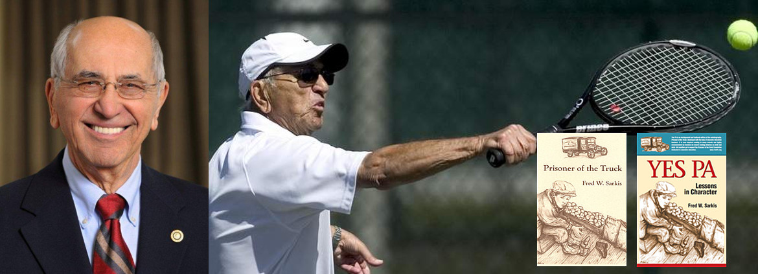

Fred Sarkis:
- 94 years-young
- tennis-player
- World War II veteran
- shares the lessons that transformed his life when he was a poor child with a bad attitude, who was bullied because he was different than his peers
- dedicates his present time to helping young people be all that they can be

